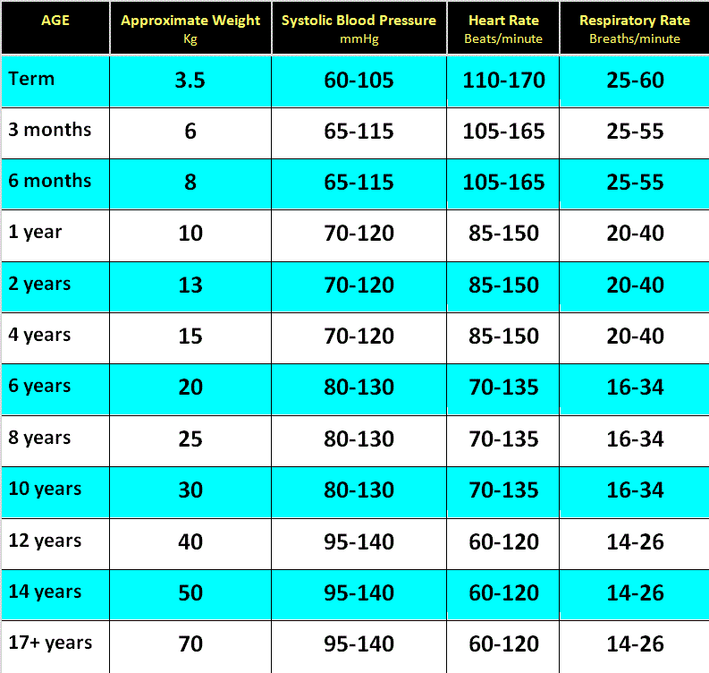

◦ These are acceptable ranges for unwell children.
◦ They are not what would be expected normal ranges for healthy children.
◦ There are many publications giving normal or acceptable ranges for physiological variables in children. Published values are quite disparate and probably reflect differeing populations and assessment methods.
◦ The values shown here match those currently being used on RCH observation charts as thresholds for patients needing review. These charts are being considered for use in all Victorian hospitals that care for children.
◦ The heart rate and respiratory rate values are drawn from the 5th & 95th centiles (bracketed for age and rounded to workable values) from: Bonafide CP, Brady PW, Keren R, Conway PH, Marsolo K, Daymont C. (2013). Development of heart and respiratory rate percentile curves for hospitalized children.
Pediatrics,131 (4), e1150-e1157).

